RANG 1
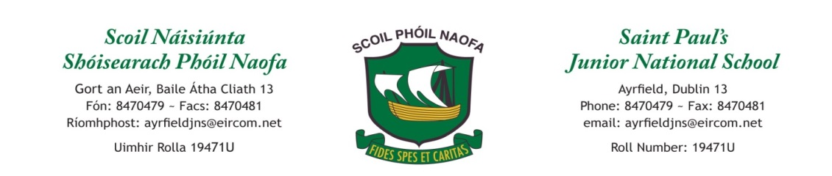

Work for First Class : Monday 20th April 2020
Monday | English: Free registration online with the following links: Please pick a book which suits your child’s reading level.  Hard -Cornflake Coin https://www.oxfordowl.co.uk/api/digital_books/1235.html  Intermediate - Red Planet  https://www.oxfordowl.co.uk/api/digital_books/1363.html  Easy - Greedy Tiger https://www.oxfordowl.co.uk/api/interactives/29270.html  Maths: Maths Challenge pg 25 .  Tables: -9 : Test yourself each day, then get someone to give you a test on Friday!  Gaeilge: Bua na Cainte pg 70 - Learn new words and complete the sentences  Geography: Small World pg 86: Talk about the different people in our school community and how they help us.  PE: PE with Joe Wicks: YouTube
Tuesday | English: The ‘ow’ sound - Watch the following video:  https://www.youtube.com/watch?v=9Ph6nnHrVwY  Read some of the following words and have a go at playing some of the games.  https://www.spellzone.com/word_lists/list-242.htm  Draw a picture of as many ‘Ow’ words as you can!  Maths: Maths Challenge pg 26. Continue with your -9 Tables.  Gaeilge: Bua na Cainte pg 72. Play the game “Feicim le mo Shúilín rud a tosnaíonn le P…”.  P.E: Get outside, put on your favourite song and do the following exercises to the music: 10 jumping jacks, 10 burpees, 10 situps, 10 push ups . Repeat!  Science: Smallworld pg 88. Explain to someone at home what a natural material is. Can you find some natural materials in your house/garden?
Wednesday | English: Read ‘How to make a Jam sandwich’ (See page 4 of doc) . If you have the ingredients, follow the instructions to make your own jam sandwich!  Maths: Revise Fractions: Draw a square, a retangle, a triangle, a circle on a page: Split the shapes into quarters.Colour ¼ of the shape.Tables: -9  Gaeilge: 10@10 as Gaeilge https://www.youtube.com/watch?v=5bBB-wYUKVg  P.E: Dance & follow the actions! https://www.youtube.com/watch?v=sNog54ovi8Q  Music: Sing these songs from the Greatest Showman and Annie- (we really enjoyed singing them in class!:)  A Million Dreams- https://www.youtube.com/watch?v=-rxgAh1bnHU  Tomorrow-https://www.youtube.com/watch?v=nNF1Rh1RQFo
Thursday | English: Practice procedural writing - Write the list of ingredients and step by step instructions on how to make a great hot chocolate!  Maths: Maths for fun: Play a maths game at home eg: snakes & ladders, tables challenge against the clock, skip counting using a ball  Gaeilge: Bua na Cainte pg 75 – revise colours and read the words. Talk about the picture using phrases- ‘Feicim......... ‘ ( I see) and ‘Tá______________sa phictúir’ ( There is ___________ in the picture). Then colour the picture.  P.E: Try some Minecraft themed yoga https://www.youtube.com/watch?v=02E1468SdHg  History: Talk to a grandparent or parent/guardian about how school was different when they were young. Write 3-5 sentences and a draw picture about how school life was different for them.
Friday | English: Handwriting: page 44  Maths: -9 Tables Test! Maths Challenge pg 27  Gaeilge: Play a game of: Deir Ó Gradaigh (Simon Says)  Deir Ó Gradaigh bí ………. ag rith ( running) ag siúl ( walking), ag léim ( jumping) ag ithe (eating) ag ól (drinking) ag damhsa (dancing) ag snámh ( swimming), ag gáire (laughing) ag caoineadh ( crying).  P.E: GAA Kick & Catch Challenge https://youtu.be/h9WUPAV3x-s  Art: Take a toilet roll/kitchen roll (one that is finished) and make something from it maybe a person or animal...use your imagination😊

Extra activities below, if required, including useful websites (for self – directed learning)
Maths- Focus on fractions
- Fractions game : https://www.twinkl.ie/go/resource/tg-ga-92-pizza-fractions-game
- Practice your tables: Half of : https://www.topmarks.co.uk/maths-games/hit-the-button
- CJ Fallon online ( free to access, just needs to be set up initially) : Figure it out 1 pg 25: revision
English- Focus on Procedures
- Video – How to make a jam sandwich https://www.youtube.com/watch?v=w2KxoWtb2VE
- Video - How to Sneak your monster into school https://www.youtube.com/watch?v=wr19EXKW2XI&list=PL1W00rU-L2c6QwiOFBnHGmWxuRQeJoiCg&index=6
- Additional e-books https://www.worldbookonline.com/kids/home
Gaeilge
- TG4- https://www.tg4.ie/ga/player/catagoir/gasuir/
Children can watch a programme in Irish in order to continue exposure to the language.
- CJ Fallon online- Leigh sa bhaile- Page 1- Mo Chlann https://www.cjfallon.ie/
- https://rtejr.rte.ie/rtejr-blog/yoga/2016/05/twigin-yoga-episode-1-an-crann-2/ Yoga videos in Irish / Yoga as Gaeilge
- https://www.tg4.ie/en/player/categories/childrens-tv-shows/ TG4 kids programmes as gaeilge
SESE (Extra websites)
- National Geographic for kids https://kids.nationalgeographic.com/
- Ask About Ireland History and Geography resources http://www.askaboutireland.ie/learning-zone/primary-students/
- Science Foundation Ireland https://www.sfi.ie/engagement/discover-primary-science-and-maths/activities-search/

Contact Teachers:
Ms. Munnelly : msmunnelly@stpaulsjns.ie
Ms. O’Neill : msoneill@stpaulsjns.ie
Ms. O’Connor : msoconnor@stpaulsjns.ie

How to make a jam sandwich

You need: Bread Butter

Jam Plate Knife

- First pick up the knife.
- Spread the butter across the bread. 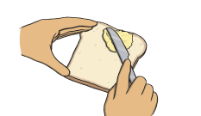

- Next spread the jam across the butter. 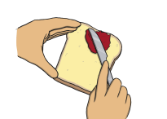

- Put the second piece of bread on top.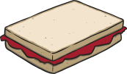

- Cut the sandwich in half with the knife. 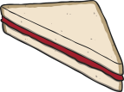

- Place the sandwich on a plate. 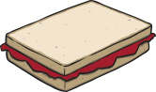

- Eat the sandwich!

