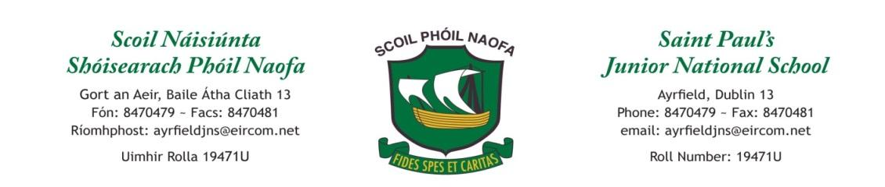
Work for Second Class: 15th -19th June 2020
All lessons marked with * are priority. Please do these items first.
Maths hands-on activities:
- Bake something. Take note of weight g/kg, volume ml/l, temperature (degrees Celsius), and time minutes and hours.
- Measure the length, width or height of 10 things in your home.
- Spend 30 minutes tidying your room. Count the amount of things that you put away.
Monday | English: *Word Wizard pg 103 Day 1* Extension pg 106 &107  *Please spend at least 15 minutes reading each day. *  Maths: Revision *Find an unfinished page in your book and complete. *  Gaeilge: *Ag Siopadóireacht Lesson 1 pg 93*  P.E: Joe Wicks on YouTube, Cosmic Kids Yoga, 10@10 as Gaeilge or Gonoodle  Other: Small World: Communication pg 92 & 93 A & C  Practice your prayers.
Tuesday | English: *Word Wizard pg 103 Day 2* Extension pg 106 &107  Maths: *Find an unfinished page in your book and complete. *  Gaeilge: *Ag Siopadóireacht Lesson 3 pg 95*  P.E: Joe Wicks on YouTube, Cosmic Kids Yoga, 10@10 as Gaeilge or Gonoodle  Other: Small World: Communication pg 92 & 93 A & C
Wednesday | English: *Word Wizard pg 104 Day 3* Extension pg 108  Maths: *Find an unfinished page in your book and complete. *  Gaeilge: *Ag Siopadóireacht Lesson 4 pg 96*  P.E: Joe Wicks on YouTube, Cosmic Kids Yoga, 10@10 as Gaeilge or Gonoodle  Other: *Small World Electricity pg 94* https://www.youtube.com/watch?v=Uf76pThNXZc
Thursday | English: *Word Wizard pg 104 Day 4* Extension pg 108  Maths: *Find an unfinished page in your book and complete. *  Gaeilge: *Ag Siopadóireacht Lesson 6 pg 97*  P.E: Joe Wicks on YouTube, Cosmic Kids Yoga, 10@10 as Gaeilge or Gonoodle  Other: Small World Electricity pg 95
Friday | English: *Word Wizard pg 105*  Maths: *Find an unfinished page in your book and complete. *  Gaeilge: *Ag Siopadóireacht Lesson 8 pg 98*  P.E: Joe Wicks on YouTube, Cosmic Kids Yoga, 10@10 as Gaeilge or Gonoodle  Other: Find out 5 facts about one of your sporting heroes or read about Katie Taylor pg Small world 96
Extra activities if required including useful websites
Check out the ‘School Closure Links for Learning’ tab on the website for lots of useful ideas
English
Reading: https://www.oxfordowl.co.uk/?selLanguage=en&mode=hub
Click on my class login. Usernames and passwords are case sensitive and observe spaces.
Username: ms maguire Password: Room5
Username: ms dutton Password: Room8
Gaeilge
TG4- https://www.cula4.com/en/shows/mo-shaol-do-shaol/

Contact Teacher: msmaguire@stpaulsjns.ie msdutton@stpaulsjns.ie

