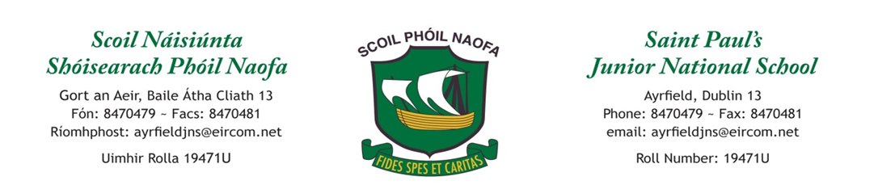

Supervision Policy St. Paul’s J.N.S.

The school will be open to receive pupils at 8.50am. No responsibility is accepted for pupils arriving before that time or on wet mornings.
The Deputy Principal is responsible for drawing up and updating the Supervision Rota which is made known to each person on the rota. In the event of a planned absence the teacher arranges to swap supervision duties with another teacher. In the event of an unplanned absence the deputy principal arranges for the supervision ‘buddy’ to supervise.
During break time one teacher supervises the yard together with an SNA (can also be aided by junior infant parents). Children are obliged to comply with the rules of the yard which include no running in quiet areas, keeping hands and feet to themselves, no spitting, freezing on the first bell and walking to their line and lining up on the second bell.
The teacher supervising the yard remains on the yard until each line is collected by their class teacher.
On wet days the supervisor and SNAs patrol the classrooms. Children must remain seated during wet playtimes.

Reviewed and ratified by the Board of Management: 26th November 2018

Signed: _____________________________ (Fr. Paddy Boyle, Chairperson.)

Review date: November 2020

