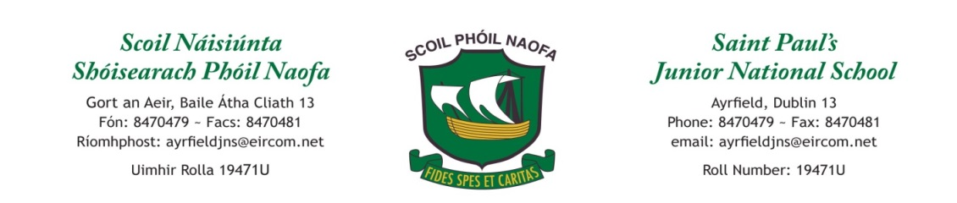

Weekly Plan - Junior Infants Class : Monday 20th April 2020
If you feel it would be more helpful to keep organised during this time, you might like to get a copy for work that your child completes over this time. A 15A project copy would be the most suitable. A Junior Sum copy may also be helpful. It is not compulsary to get these copies.
Monday  *We understand that some of you don’t speak Irish so the content is optional* | English:Oral News: Day of the week, date and month. Describe the weather. Make a weather chart and fill it in daily. (sample below). Sight reading words - the, to, and , he, a  Maths: Number 5 – practise formation. Make 5 Easter Eggs/ chicks/bunnies with playdoh. Make a group of items in your kitchen. E.g. put 5 spoons in a bowl. Find 5 on your dice.  Irish: Sa Bhaile (at home) – New words Díon (Roof) Simléar (chimney)  P.E: Do 5 jumping jacks, 5 bunny hops, 5 sausage rolls. Repeat 5 times!
Tuesday | English: Read book or watch on YouTube story Hansel & Gretel. Discuss the story and name all the characters. Draw a picture of the story. Writing – Just Handwriting book page 34 – ‘s’  Maths: Count 1-10, take turns saying a number. Make your own numberline 1-10. Go on a hunt for shapes in your house. Find a circle shape, a square shape, a rectangle shape and a triangle shape.  Irish: Sa Bhaile – New words Ballaí (walls) Fuinneog (window)  P.E: Build an obstacle course.  SESE: Topic – Electrcity - Think of 6 things in your house that use electricity. If you wish to draw a picture in your copy of 2 things in you house that use electricy.
Wednesday | English: Practice the rhyme Jack & Jill. Draw a picture of the rhyme.  Maths: Online Game: https://ie.ixl.com/math/jr-infants/count-objects-up-to-5  Irish: Sa Bhaile – New word doras (door) and revise díon, simléar, ballaí, fuinneog  P.E: Have a potato and spoon race.  SESE: Animals and their young: What do you call a baby dog, cat, cow, horse, pig, sheep, butterfly? Link for Twinkl PowerPoint is useful. https://www.twinkl.ie/resource/us-t-2546349-all-about-farm-animals-powerpoint
Thursday | English: Just Handwriting book page 35 – Letter s  Maths: Recite number rhyme – 5 Little Monkeys and do the actions. https://www.twinkl.ie/resource/t-t-23013-5-little-monkeys-jumping-on-the-bed-poster  Irish: Watch the story Cinnín Óir https://www.youtube.com/watch?v=91Aa8lBXUos  P.E: Make animal movements - hop like a bunny, jump like a frog, crawl like a crab, fly like a bird etc.
Friday | English: Play a game of I Spy something that starts with the sound ……(make sound)  Maths: Operation Maths Junior Infants p64 (Colour the Bears)  Irish: Revise colours: Dearg (red)& buí (yellow)  P.E: Have a three-legged race.  SESE/Art: Make your own playdoh.(Optional) 230 ml – warm water, 2 tablespoons cooking oil, 250g plain flour, 65g salt, 2 teaspoons of cream of tartar, a few drops of food colouring. See Explore with Me book page 30.

Optional extra websites for this week
Weather Chart
Monday | Tuesday | Wednesday | Thursday | Friday

Websites:
https://www.oxfordowl.co.uk/for-home/find-a-book/library-page/ Library reading at home
https://www.starfall.com/h/ Sounds and blending
https://ie.ixl.com/ Maths and English

Apps:
Unite books app – reading
Word Reading Magic – blending words

Contact Teacher – Room 1 mstreanor@stpaulsjns.ie
Contact Teacher – Room 2 msmcdermott@stpaulsjns.ie

